1 - GameMaker Basics

- Setup
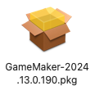
- Install gm2
- Run and create game 1: Basics

- Sprites -> Create sprites: edit and fill square with colour

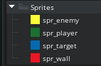

- Objects -> Create objects for each sprite: create and code later
- Create obj_manager – no sprite: used to contain game settings

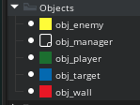

- Rooms -> Open Room 1 and re-name as rm_level1
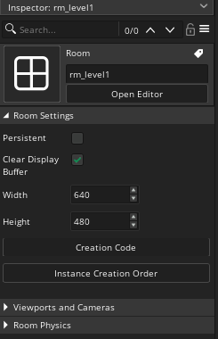
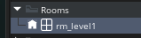

- Make modifications as shown:

- You can set the grid at the top right corner:

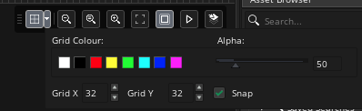

- Instances are representations of objects and have an ID which the code can identify.
Place instances of objects on the instances layer:
- Select the obj_wall object and place in the room
- To stretch it:
  - click in the instance and move the cursor to an edge
  - a <-|-> symbol appear
  - click and drag to enlarge the instance

- See a basic layout below:

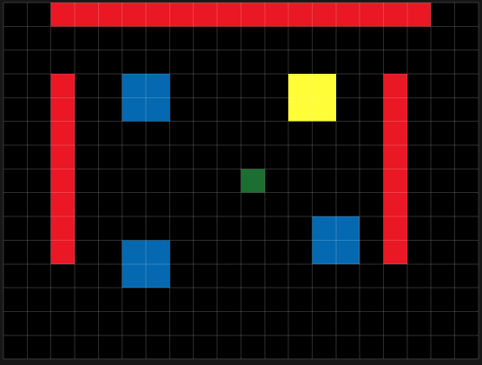

- Save your work.

** Next -> 2-Basic interactions **

