1 - GameMaker Basics

1. Setup

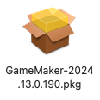

* **Install gm2**
* Run and create game 1: ***Basics***

1. **Sprites** -> Create **sprites**: edit and fill square with colour

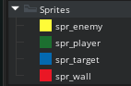

1. **Objects** -> Create **objects** for each **sprite:** create and code later

* Create **obj_manager** – no sprite: used to contain game settings

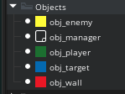

1. **Rooms** -> Open Room 1 and re-name as rm_level1

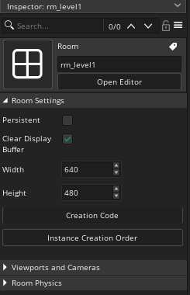



* Make modifications as shown:
* You can set the grid at the top right corner:

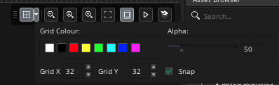

1. **Instances** are *representations of objects* and have an ID which the code can identify.

Place **instances** of objects on the **instances layer**:

* Select the **obj_wall** object and place in the room
* To stretch it:
  + click in the instance and move the cursor to an edge
  + a <-|-> symbol appear
  + click and drag to enlarge the instance
* See a basic layout below:

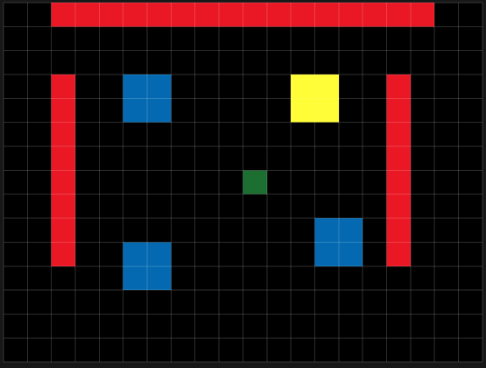

1. Save your work.

** Next -> 2-Basic interactions **